# Ex No 8

Implement SVM/Decision tree classification techniques

# AIM:

To Implement SVM/Decision tree classification techniques using R.

# PROCEDURE:

* Collect and load the dataset from sources like CSV files or databases.
* Clean and preprocess the data, including handling missing values and encoding categorical variables.
* Split the dataset into training and testing sets to evaluate model performance.
* Normalize or standardize the features, especially for SVM, to ensure consistent scaling.
* Choose the appropriate model: SVM for margin-based classification, Decision Tree for rule-based classification.
* Train the model on the training data using the ‘fit’ method.
* Make predictions on the testing data using the ’predict’ method.
* Evaluate the model using metrics like accuracy, confusion matrix, precision, and recall.
* Visualize the results with plots, such as decision boundaries for SVM or tree structures for Decision Trees.
* Fine-tune the model by adjusting hyperparameters like `C` for SVM or

`max_depth` for Decision Trees.

# CODE:

**SVM.R:**

# Install and load the e1071 package (if not already installed) install.packages("e1071")

library(e1071)

# Load the iris dataset

data(iris)

# Inspect the first few rows of the dataset head(iris)

# Split the data into training (70%) and testing (30%) sets set.seed(123) # For reproducibility

sample_indices <- sample(1:nrow(iris), 0.7 * nrow(iris)) train_data <- iris[sample_indices, ]

test_data <- iris[-sample_indices, ] # Fit the SVM model

svm_model <- svm(Species ~ ., data = train_data, kernel = "radial") # Print the summary of the model

summary(svm_model) # Predict the test set

predictions <- predict(svm_model, newdata = test_data) # Evaluate the model's performance

confusion_matrix <- table(Predicted = predictions, Actual = test_data$Species) print(confusion_matrix)

# Calculate accuracy

accuracy <- sum(diag(confusion_matrix)) / sum(confusion_matrix) cat("Accuracy:", accuracy * 100, "%\n")

# Decision Tree.R:

# Install and load the rpart package (if not already installed) install.packages("rpart")

library(rpart)

# Load the iris dataset data(iris)

# Split the data into training (70%) and testing (30%) sets

set.seed(123) # For reproducibility

sample_indices <- sample(1:nrow(iris), 0.7 * nrow(iris)) train_data <- iris[sample_indices, ]

test_data <- iris[-sample_indices, ] # Fit the Decision Tree model

tree_model <- rpart(Species ~ ., data = train_data, method = "class") # Print the summary of the model

summary(tree_model)

# Plot the Decision Tree plot(tree_model) text(tree_model, pretty = 0) # Predict the test set

predictions <- predict(tree_model, newdata = test_data, type = "class") # Evaluate the model's performance

confusion_matrix <- table(Predicted = predictions, Actual = test_data$Species) print(confusion_matrix)

# Calculate accuracy

accuracy <- sum(diag(confusion_matrix)) / sum(confusion_matrix) cat("Accuracy:", accuracy * 100, "%\n")

# OUTPUT: SVM in R:

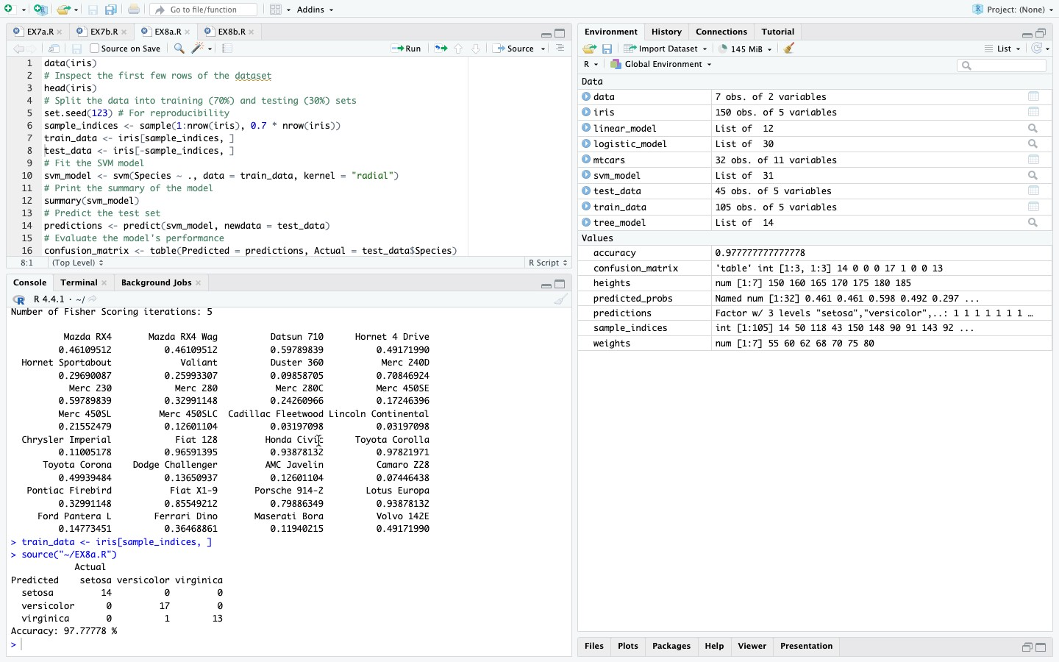

**Decision tree:**

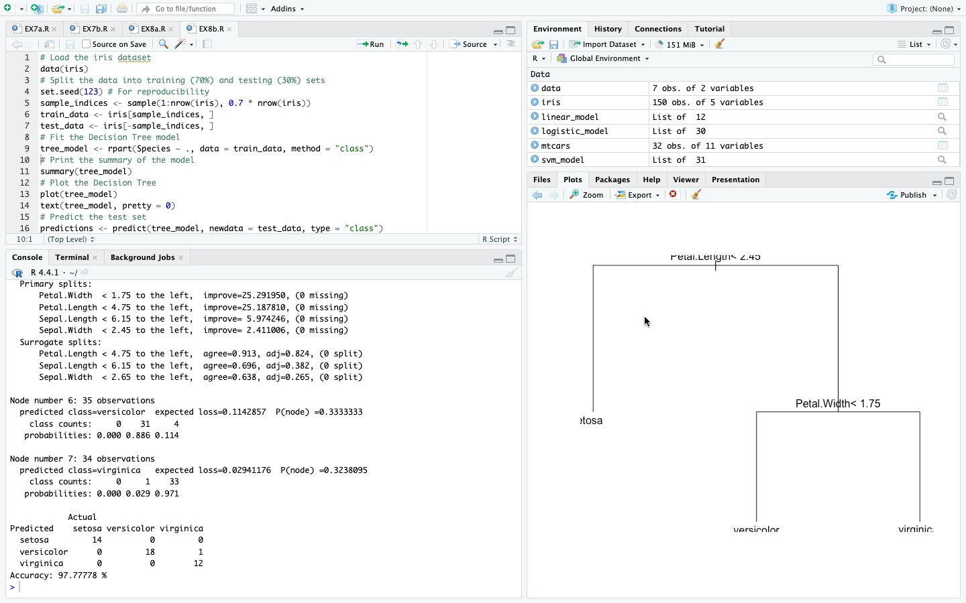

# RESULT:

Thus, Implement SVM and Decision tree classification techniques has been successfully executed.